Accessing the BusinessKnight Mobile App
- Search for “Symplicity Jobs and Careers” in either:
“Google Play Store” (For Android)
https://play.google.com/store/apps/details?id=com.symplicity.csmandroid

“App Store” (For iPhones):
https://apps.apple.com/us/app/symplicity-jobs-and-careers/id1239828027

You will look for the app with the below icon:
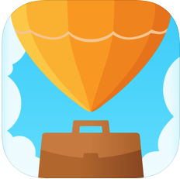

- Once installed. Open the app and select “Rutgers University” as your school.
It will have the below icon:

- Once your School is selected, you will be brought to the “Login” page.
Select the option for “Single Sign On”, and use your NetID login credentials.

