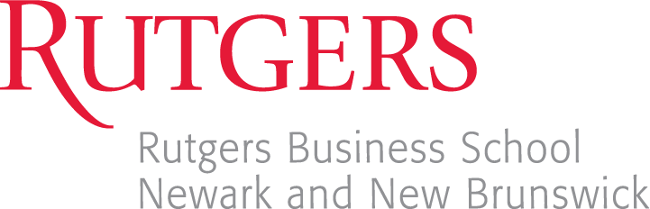

Advanced Certification in Procurement

The Advanced Certification in Procurement (ACP) represents an important addition to the Rutgers Business School undergraduate degree in Supply Chain Management (SCM). Intended for students planning a career in supply chain management, this certificate will demonstrate mastery of key procurement topics and skills needed in today’s global business environment.

Certification

The ACP will be issued by the Rutgers Center for Supply Chain Management through its Advanced Global Supply Chain Leadership Academy. The Rutgers Center is affiliated with over 20 major, global corporations and has ties to other leading universities (not only in the U.S. but throughout the world) that specialize in procurement and supply chain management.

Exam

To obtain the ACP, students must pass a 1.5 hour (90-minute), comprehensive, closed-book, multiple choice exam with a grade of 70 or higher. The exam consists of 50 multiple choice questions, each worth 2 points, for a total of 100 points. The exam will cover important topics such as procurement strategy, organization, processes, information technology, contract law, cost management and supplier relationship management. The best way to study for this exam is by reviewing your text and notes from the Procurement and Global Sourcing class.

Eligibility

RBS SCM undergraduate students who have successfully completed the Procurement and Global Sourcing course (29/33:799:305), or who are currently enrolled in the course, are eligible to take the exam.

Date and Time of Exam

The certification exam will be offered in-person for NWK and for NB in Fall 2025:

- NWK – Monday, December 1st, 2025- 1:00pm – 2:30pm, 1WP Room 418
- NB –Monday, December 1st, 2025- 1:00pm – 2:30pm, 100 Rock Room TBD

Exam Rules and Regulations
The APC exam will be a paper exam, and your computer is not needed.
This is a closed-book exam. Textbooks, notes, and electronic materials will not be allowed during the exam. No calculator is needed. Any violation to the exam rules will result in a zero grade and disqualify you from the certificate.

Registration and Cost for Dec ^{1st} NEWARK in-person

REGISTRATION FOR Dec 1st NEWARK IN-PERSON EXAM
Cost is $25. For registration and payment for Dec 1st in-person go to:
https://ce-catalog.rutgers.edu/coursedisplay.cfm?schID=96518

Registration and Cost for Dec 1st NEW BRUNSWICK in-person

REGISTRATION FOR Dec 1st NEW BRUNSWICK IN-PERSON EXAM
Cost is $25. For registration and payment for Dec 1st online go to:
https://ce-catalog.rutgers.edu/coursedisplay.cfm?schID=96517

General Questions about the Certification

Newark students may direct questions to Professor John Impellizzeri at: jimpellizzeri@business.rutgers.edu

New Brunswick students may direct questions to Professor John Impellizzeri at:
jimpellizzeri@business.rutgers.edu

