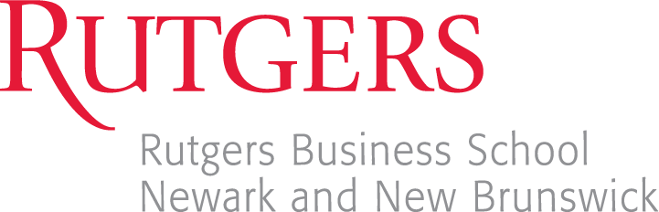

Lean Six-Sigma Green Belt Technical Certificate

The Lean Six Sigma Green Belt Technical Certificate represents an important addition to the Rutgers Business School degree. Appropriate for students planning a career in any business discipline in which process improvement is valued, this certificate will signify proficiency of key business process improvement topics and skills needed in today’s global business environment.

Certification

The Lean Six Sigma Green Belt Technical Certificate will be issued by the Rutgers Center for Supply Chain Management through its Advanced Global Supply Chain Leadership Academy. The Rutgers Center is affiliated with over 20 major, global corporations and has ties to other leading universities (not only in the U.S. but throughout the world) that specialize in procurement and supply chain management.

Exam

To obtain the Lean Six Sigma Green Belt Technical Certificate, students must pass a comprehensive, multiple-choice exam with a grade of 75% or greater. The exam will include important topics covering the six sigma DMAIC (Define-Measure-Analyze-Improve-Control) framework as well as the fundamentals of lean operations and other business improvement techniques. The format of the exam is modeled after industry standards.

Recommended books:
(BOOK-1) Six Sigma: The Breakthrough Management Strategy Revolutionizing the World’s Top Corporations (Mikel Harry & Richard Schroeder)
(BOOK-2) The Toyota Way (Jeffrey K. Liker)
(BOOK-3) LEAN THINKING (James P. Womack and Daniel T. Jones)

Eligibility

The best way to become better educated in Lean Six-Sigma is to take the Rutgers Lean Sig Sigma class. It is recommended that RBS students successfully complete one of the Lean Six Sigma courses (22:799:676), (29:799:460) or (33:799:460) before taking this exam. However, this is not a prerequisite to taking the exam.

There are also a lot of sources on the web. Some of the top-reliable ones are:
- https://isssp.org (International Society of Six Sigma Professionals)
- https://www.lean.org (Lean Enterprise Institute)
- http://leansensei.com (Lean Sensei)
- https://asq.org (American Society of Quality)
- http://www.minitab.com (MiniTab statistical software)
Date and Time of Exam
(Offered In-Person and Taken on Canvas via LockDown Browser)

The certification exam will be offered in-person simultaneously in NWK & NB in Fall 2025:

- NWK – Friday, December 5th, 2025 - 9:30am-11:30am, 1WP Room 226
- NB – Friday, December 5th, 2025 - 9:30am-11:30am, 100 Rock Room TBD

Exam Rules and Regulations
The exam will be offered on Canvas. Respondus LockDown Browser will be used to proctor the exam. Bring your own laptop with LockDown Browser preinstalled to the exam room specified above. Detailed proctoring information and instructions will be announced on the Canvas course site once you sign up for the exam.
This is a closed-book exam. Textbooks, notes, and electronic materials will not be allowed during the exam, but you are allowed to bring a handwritten one-sided sheet of paper. It is not open communication of any kind, including the use of your cell phone or any communication app on your computer. Further, you are prohibited to browse the internet during the exam. Any violation to the exam rules will result in a zero grade and disqualify you from the certificate.
Registration and Cost

REGISTRATION FOR December 5th NEWARK IN-PERSON OVER CANVAS EXAM
Cost is $25. For registration and payment go to:
https://ce-catalog.rutgers.edu/coursedisplay.cfm?schID=96516

REGISTRATION FOR December 5th NEW BRUNSWICK IN-PERSON OVER CANVAS EXAM
Cost is $25. For registration and payment go to:
https://ce-catalog.rutgers.edu/coursedisplay.cfm?schID=96515

General Questions about the Certification

Newark students may direct questions to Professor James Mentone at: james.mentone@rutgers.edu

New Brunswick students may direct questions to Professor Tony Bell at: gbell@business.rutgers.edu

